Full Name: John Yee Student ID: 12345

Wells international college

**Project Management**

Assessment Two

|  |  |  |  |
| --- | --- | --- | --- |
| Name of Student |  | ID | 1 |

**Assessment 2 – Research (Online)**

Contents

Instructions: 1

Duration: 2

Multiple-choice Questions: 2

Learning Notes: 7

What is project? 8

Please put your learning notes here: 8

Project management basic 8

Project management History 8

Project management in the future 9

Project Team 10

Document Search Index 10

## Instructions:

This is an individual assessment. Answer all the questions on the document provided by your Trainer.

## Duration:

Trainer will set the duration of the assessment.

## Multiple-choice Questions:

1. 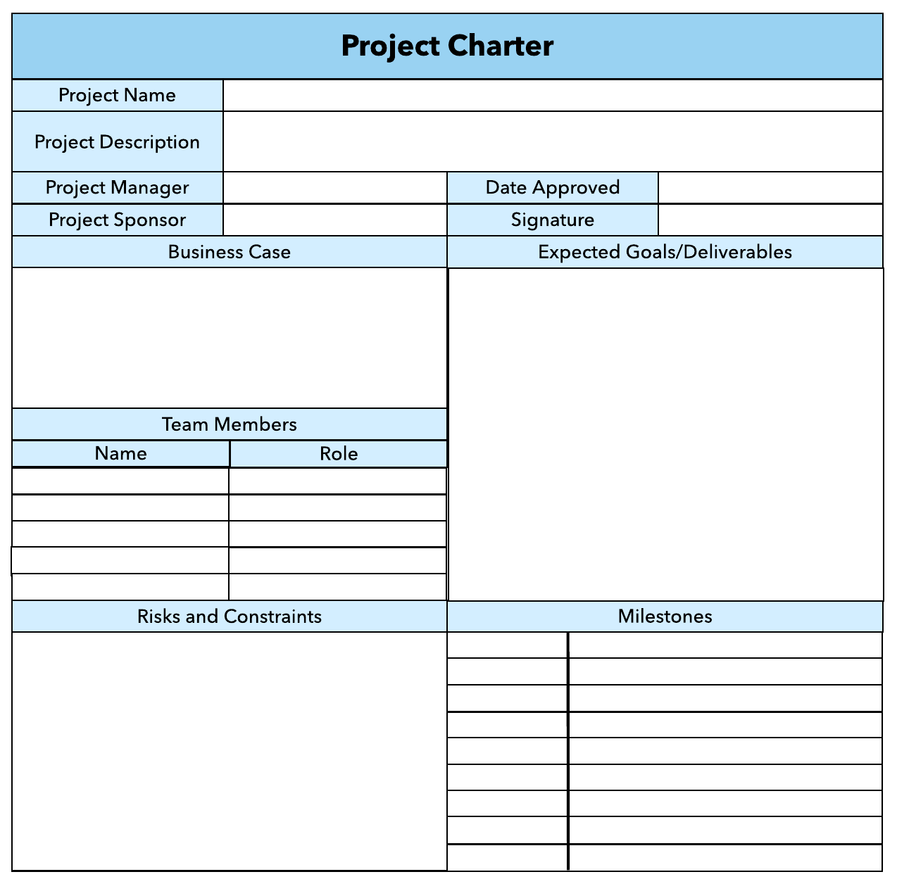What advice do we give about factoring in the commitments of project stakeholders when making your own plans?
   1. Consult student timetables to see when they might be free to attend data collection sessions.
   2. Ask external organizations what the most convenient times would be for you to visit
   3. Neither of these

d) Both A and B

Comment: Stakeholders need to be aware of the plan before implementation. Communication is the key.

Web ref: https://www.projectcentral.com/blog/manage-expectations/

1. Which of the following are essential components of a GANTT chart used to plan your project?
   1. Your home telephone number
   2. Your supervisor’s home telephone number
   3. The email address for the chair of the ethics committee
   4. None of the above

Comment: A good Gantt chart needs to include task list, timeline, progress, resources and milestones.

Web ref: https://www.teamgantt.com/what-is-a-gantt-chart

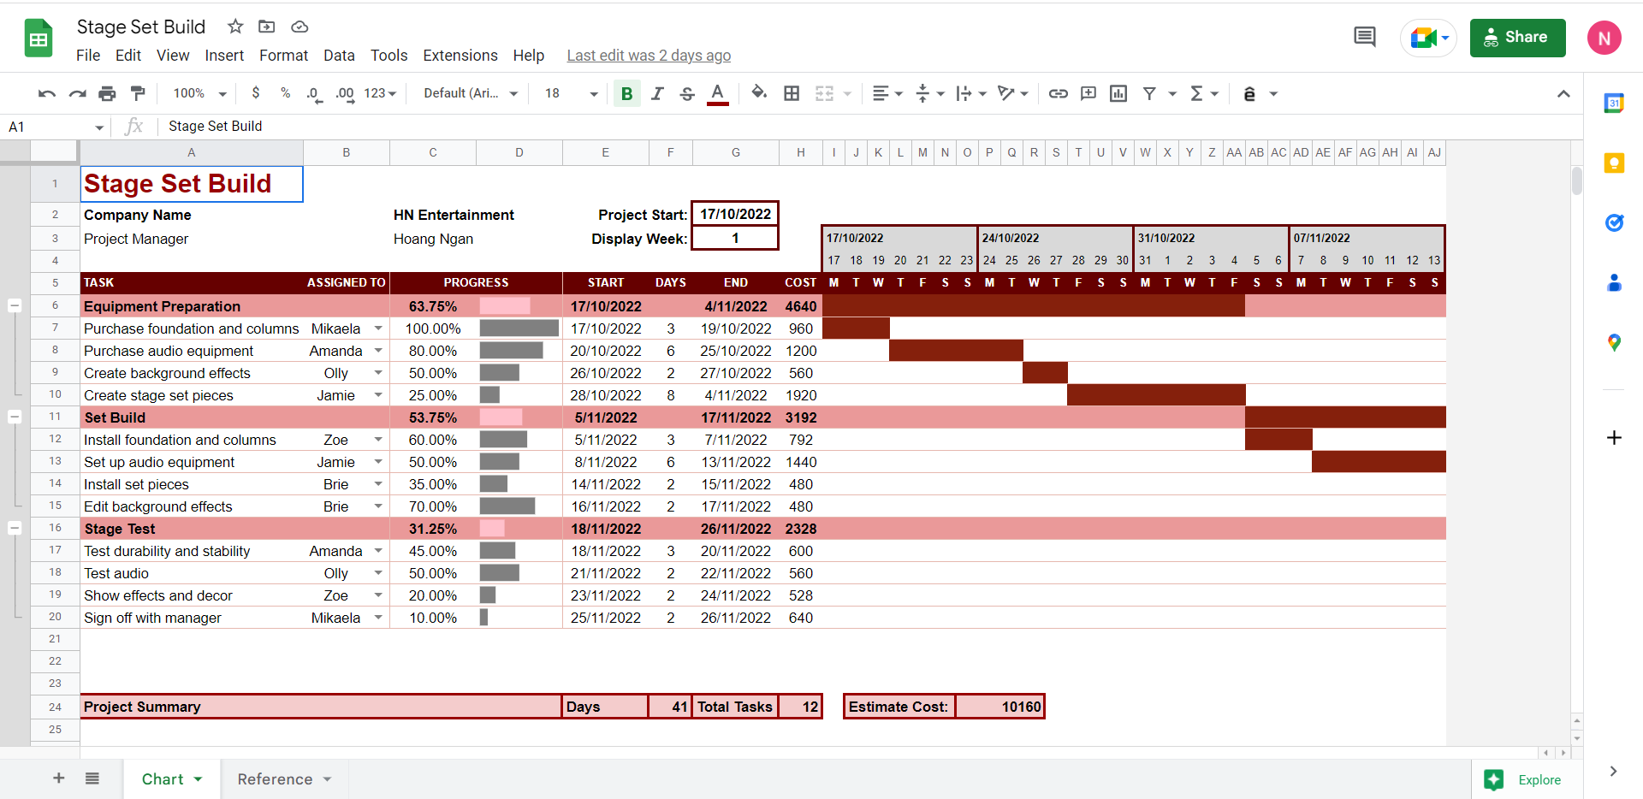

1. The intended outcome of strategy/projects integration is
   1. Clear organization focus
   2. Best use of scarce organization resources
   3. Improved communication across projects and departments
   4. Both A and C are correct
   5. A, B, and C are all correct

Comment: Project integration management involves coordinating all elements of a project, including tasks, resources, stakeholders, and deliverables. The purpose of project integration management is to ensure that processes run efficiently and meet predefined goals.

Web Ref: https://asana.com/resources/project-integration-management

1. Which of the following questions does the organization's mission statement answer?
   1. What are our long-term strategies?
   2. What are our long-term goals and objectives?
   3. How do we operate in the existing environment?
   4. What do we want to become?
   5. All of these are answered by the mission statement

Comment: A mission statement defines what line of business a company is in, and why it exists or what purpose it serves.

Web ref: https://corporatefinanceinstitute.com/resources/management/mission-statement/

1. Which of the following is not one of the requirements for successful implementation of strategies through projects?
   1. Allocation of resources
   2. Prioritizing of projects
   3. Motivation of project contributors
   4. Adequate planning and control systems
   5. All of these are requirements

Comment: To address new challenges and business concerns, organizations must constantly monitor, evaluate, and adjust their strategic initiatives. When a new strategy needs to be implemented, it’s typically up to managers to ensure it rolls out successfully.

Web ref: https://online.hbs.edu/blog/post/strategy-implementation-for-managers

1. Which of the following is the reason(s) why project managers need to understand their organization's mission and strategy?
   1. To make appropriate decisions and adjustments
   2. To be effective project advocates
   3. To be able to get their job done
   4. Both A and B are correct
   5. A, B, and C are all correct

Comment: For a project manager to become truly successful, they must have the ability to align their project within the greater context of the company. Understanding the core business strategy is the key to reaching a positive outcome.

Web ref: https://blog.planview.com/project-managers-care-business-strategy/#:~:text=Understanding%20the%20company%20strategy%20helps,project%20success%20are%20much%20greater.

1. Which of these is the highest priority and first strategy required for any organizational change?

a) Communication

* 1. Stress management
  2. Negotiation
  3. Learning
  4. Employee involvement

Comment: Communication is the highest priority and first strategy required for any organizational change. It reduces the restraining forces by keeping employees informed about what to expect from the change effort.

Web ref: [http://ndl.ethernet.edu.et](http://ndl.ethernet.edu.et/bitstream/123456789/79485/6/organizational%20change-CHAPTER%20THREE.docx)

1. Which of the following is not a procedure to obtain an understanding risk in the planning stage (described in ISA 315):
   1. Inquiries of management
   2. Analytical procedures
   3. Observation and inspection
   4. Procedures for sampling audit tests

Comment: A risk is anything that could potentially impact your project’s timeline, performance or budget. Risks are potentialities, and in a project management context, if they become realities, they then become classified as “issues” that must be addressed with a risk response plan.

Web ref: https://www.projectmanager.com/blog/risk-management-process-steps

1. Assessment of control risk includes three steps. Which of the following is not one of these steps?
   1. Obtaining an understanding of internal controls and documentation of the controls
   2. Evaluate sufficiency and appropriateness of audit evidence
   3. An initial assessment and response to assessed risk based on the design of internal controls resulting in an audit planning memorandum and audit plan
   4. A final assessment based upon test of controls of operating effectiveness

Comment: Assessment of control risk is the process of evaluating the effectiveness of the design and operation of an entity’s internal control structure policies and procedures in preventing or detecting material misstatements.

Web ref: https://www.iedunote.com/control-risk

1. Which of the following are not common internal control documentation techniques used by auditors?

a) Questionnaires

* 1. Company internal control manuals
  2. Narrative descriptions
  3. Check lists

Comment: Auditor documents the understanding in the form of completed internal control questionnaires, flowcharts, and narrative memoranda.

Web ref: https://www.iedunote.com/control-risk

1. Overall response to assessed risk may include:
   1. Identify the absence of key controls (where controls are lacking)
   2. Identify existing controls
   3. Incorporating additional elements of unpredictability in the selection of further audit procedures to be performed
   4. Determine potential material misstatements that could result

Comment: When different types of evidence support the same conclusion about the effectiveness of control, the degree of assurance increases.

Web ref: https://www.iedunote.com/control-risk

1. 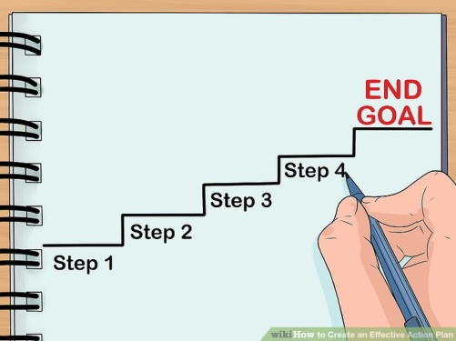Action plan Should be
   1. Specific
   2. Countable
   3. Realistic
   4. Achievable

Comment: An action plan is not something set in stone. As your organization grows, and surrounding circumstances change, you will have to revisit and make adjustments to meet the latest needs.

Web Refer: https://creately.com/blog/diagrams/how-to-write-an-action-plan/

1. Which of the following is not a function of Project Management Tool?
   1. Plan a project
   2. Manage Tasks
   3. Manage Issues
   4. Time Tracking
   5. None of above

Comment: Project management tools are a set of software designed to help project teams to plan a project, track & manage the projects to achieve the defined project goals within the time. It also helps team members to collaborate effectively and accelerate the projects to meet the specified constraints.

Web ref: https://www.zoho.com/projects/project-management-tools.html

1. John, the project manager for the ERP Project, is about to complete the project phase review. The completion of a project phase is also known as which of the following?

a) A lesson learned

* 1. A kill point
  2. Earned value management
  3. Conditional advancement

Comment: Earned value (EV) is a way to measure and monitor the level of work completed on a project against the plan. Simply put, it’s a quick way to tell if you’re behind schedule or over budget on your project.

Web ref: https://www.wrike.com/project-management-guide/faq/how-to-calculate-earned-value-in-project-management/

1. Which of the following is not a key stakeholder in a project that creates a service internal to an organization?
   1. The project manager
   2. External customers
   3. Project vendors
   4. Project team members

Comment: In this case, customers are considered external stakeholders within the business context of a project.

1. Managing a project is best described as which one of the following?
   1. Establishing direction
   2. Functional controls over the project team and stakeholders
   3. Consistently producing key results expected by stakeholders
   4. Motivating and inspiring the project team to produce results that are expected by project stakeholders

Comment: Project management is the application of processes, methods, skills, knowledge and experience to achieve specific project objectives according to the project acceptance criteria within agreed parameters. Project management has final deliverables that are constrained to a finite timescale and budget.

Web ref: https://www.apm.org.uk/resources/what-is-project-management/#:~:text=Definition,a%20finite%20timescale%20and%20budget.

1. You are the project manager for your organization. Influencing your organization requires which of the following?
   1. An understanding of the organizational budget
   2. Research and documentation of proven business cases
   3. An understanding of formal and informal organizational structures
   4. Positional power

Comment: The organizational structure of your business refers to the way management levels are established, and the way decisions are made and implemented to achieve your desired goals. As a business owner or company leader, it’s your responsibility to decide whether the organizational structure that underlies your business is formal or informal.

Web ref: https://smallbusiness.chron.com/basic-types-organizational-structure-formal-informal-982.html

1. What is the difference between a standard and a regulation?
   1. Standards are mandatory; regulations are not.
   2. Standards are optional; regulations are not.
   3. Regulations and standards are essentially the same.
   4. Regulations are usually mandatory; standards may be seen as guidelines.

Comment: Standards aren’t the same as regulations and following a standard doesn’t guarantee that you’re within the relevant laws. In fact standards rarely cite the law as legislation could change within the lifetime of the standard.

Web ref: https://www.bsigroup.com/en-GB/standards/Information-about-standards/standards-and-regulation/

1. Which of the following is an example of a deliverable at the end of the requirements-gathering phase in a software design project?
   1. Responsibility matrix creation
   2. Detail design document
   3. Business needs
   4. Project team assembled

Comment: Business requirements define what an organization will accomplish with the project. They’re gathered during the initiation phase of the project life cycle, but project managers need to monitor them throughout the project timeline, as they can change.

Web ref: https://www.projectmanager.com/blog/requirements-gathering-guide

1. At what point in a project would a kill point be acceptable?
   1. When a project team member is not performing as planned
   2. When a project reaches the end of a project phase
   3. When a project reaches the end of its budget
   4. When a project manager determines the project team cannot continue

Comment: The kill point is the stage gate or phase review. At the review, the progress of the project is evaluated and a decision is made whether to continue or cancel the project.

Web ref: https://www.infosecinstitute.com/skills/?utm_source=skillset&utm_medium=infosec%20network

1. Of the following, which is not an exit criterion?
   1. Customer sign-offs
   2. Quality metrics
   3. Stakeholder analysis
   4. Regulatory inspections

Comment: Exit criteria address the issue of how to determine when testing has been completed.

Web ref: https://www.oreilly.com/library/view/managing-the-testing/9780471223986/9780471223986_exit_criteria.html

1. At which point is the risk of failure the least but the consequence of failure the highest?

a) During the early stages

* 1. During the middle stages
  2. During the final stages
  3. Risk of failure is even across all project phases

Comment: The final stage, Closing, is the least risky, but the risk of project failure is still present. Most failure risk in the Closing stage is tied to earlier unaccounted-for issues that do not present themselves until the very end.

Web ref: https://www.mentorworks.ca/blog/business-strategy/project-failure-risk-strategies/

1. In project estimation, project manager has to provide an expert judgement, which are considered of the following EXCEPT:
   1. Impact of inflation over the project lifecycle
   2. Required labour and labour rates
   3. Material costs and assumptions
   4. Costs of quality
   5. All of above
   6. None of above

Comment: Expert judgment is a technique in the project planning process that refers to making a judgment based on skill, expertise, or specialized knowledge in a particular area.

Web ref: https://www.wrike.com/project-management-guide/faq/what-is-expert-judgment-in-project-management/

1. Which component is/are included in Quality Management Plan
   1. Quality objectives
   2. Key project deliverables
   3. Quality standards
   4. Quality control and assurance activities
   5. All of above

Comment: Quality Management is the act of overseeing all activities and tasks that must be accomplished to maintain a desired level of excellence. This includes the determination of a quality policy, creating and implementing quality planning and assurance, and quality control and quality improvement.

Web ref: https://acqnotes.com/acqnote/careerfields/quality-management-plan-qmp

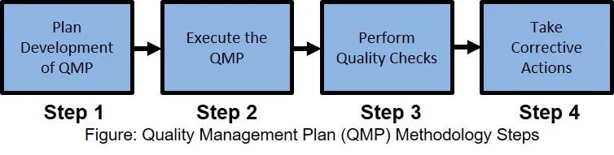

1. What's an activity sequencing
   1. The process for identifying and documenting dependencies among schedule activities
   2. The process for identifying critical activities
   3. The process for identifying ordering and schedule activities
   4. The process for planning the project

***Activity sequencing*** reviews all activities in the WBS with the goal of identifying relationships between them and classifying all the timing relationships among tasks. These relationships (aka "linkages", "dependencies", "predecessors"). Task timing relationships are important because they control task sequencing and task start and end dates. There are four types of task relationships:  
A ***finish-to-start relationship***

A ***start-to-start relationship***

A ***finish-to-finish relationship***

A***start-to-finish relationship***

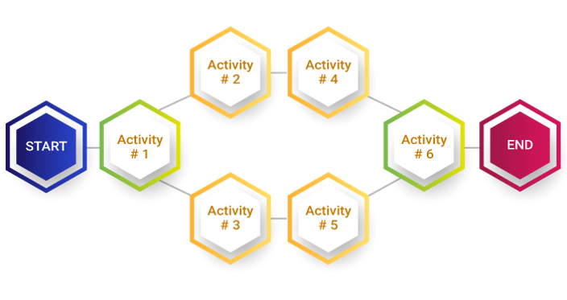

Comment: The strategy of distinguishing and authenticating affiliates amidst the project activities, and sequence activities illustrates the consistent planning of work to get the highest effectiveness of the project constraints. Throughout the project, the process of the execution plan is for better performance.

Web ref: https://www.invensislearning.com/blog/sequence-activity/

## Learning Notes:

<https://www.youtube.com/watch?v=rBSCvPYGnTc&t=1323s>

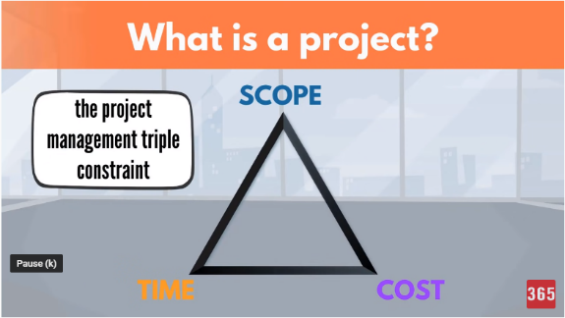A project is something extremely useful for people that want to accomplish their future ideas.

A project is a temporary endeavour undertaken to create a unique product, service or result.

Day to day activities have no end date.

Project on the other hand have a strict expiry date.

Project output is product or service or result.

Project shows different scope.

If the scope is not unique, this is a regular business process.

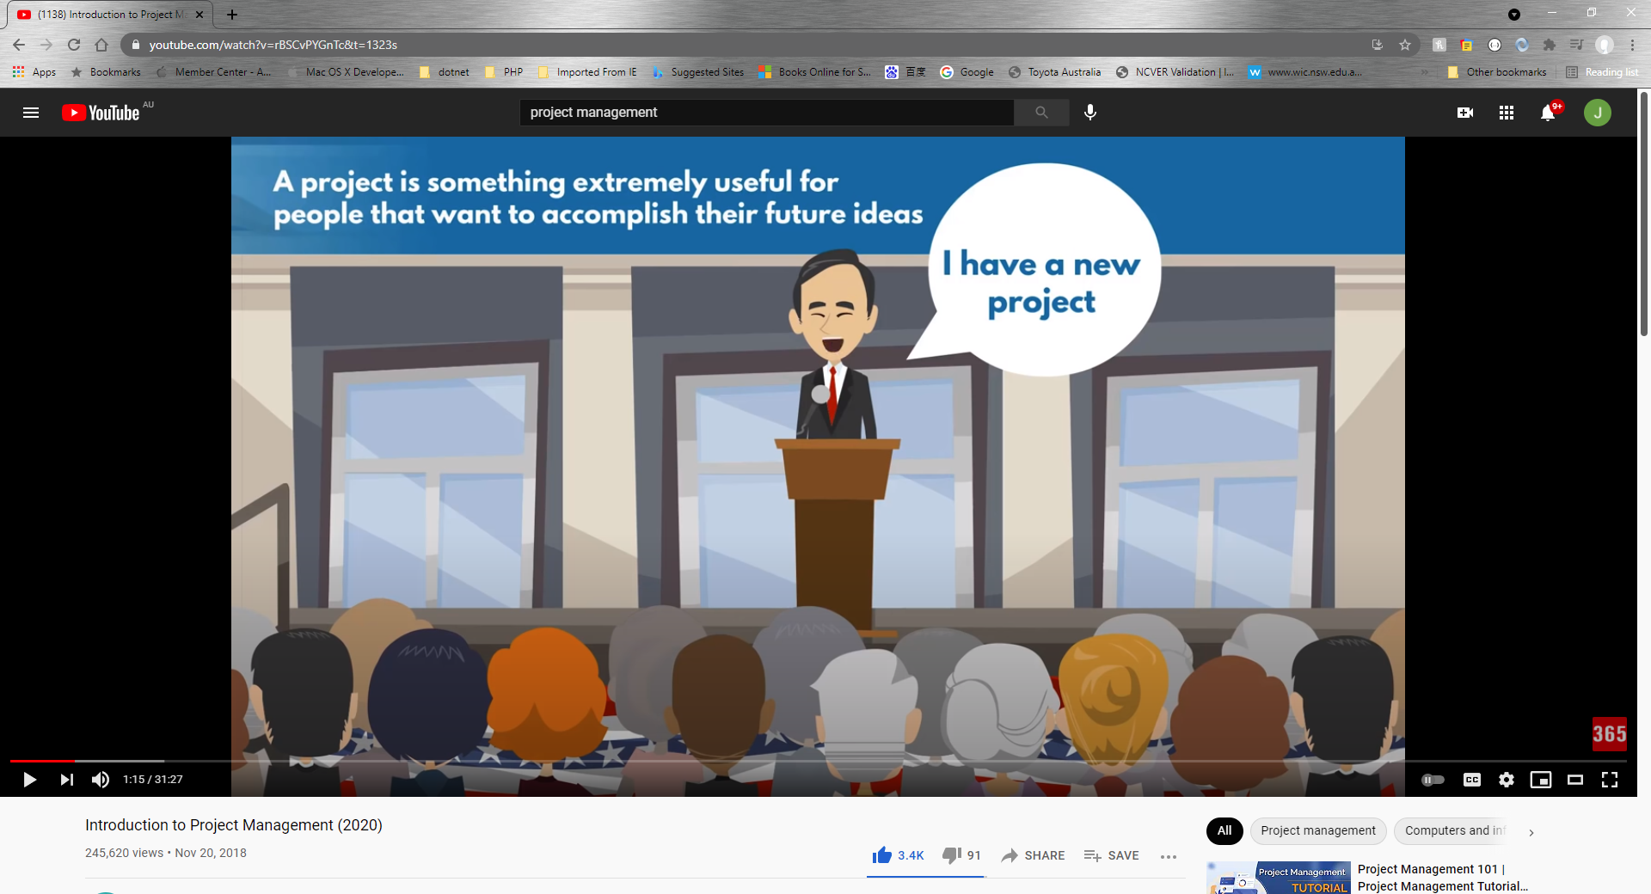

## What is project?

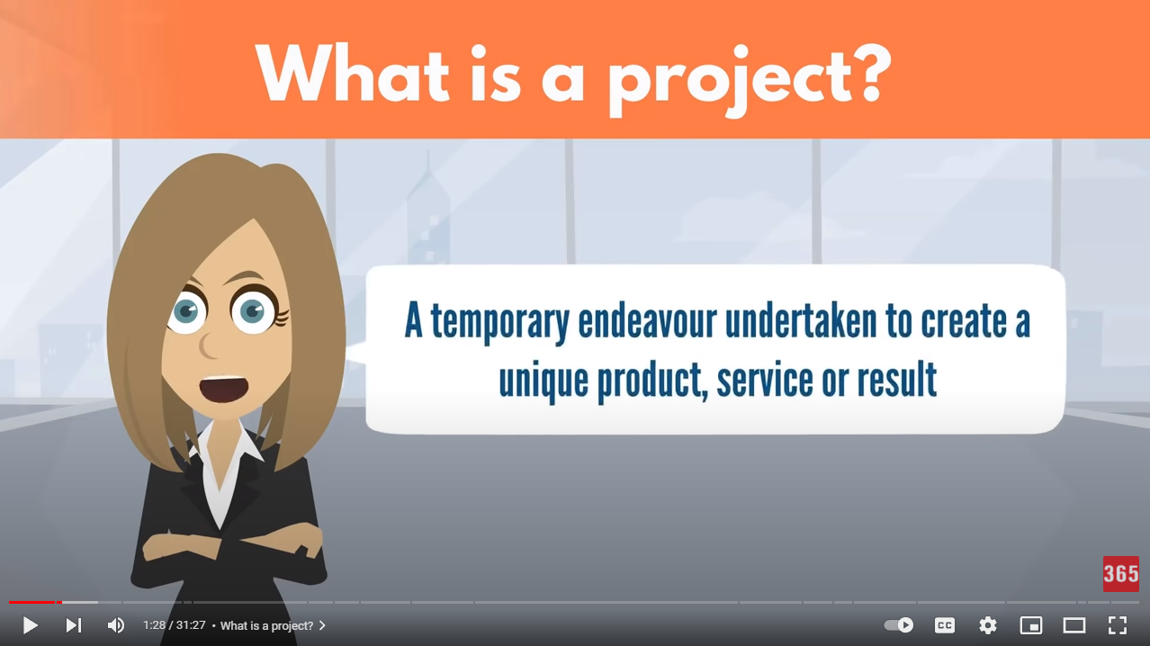

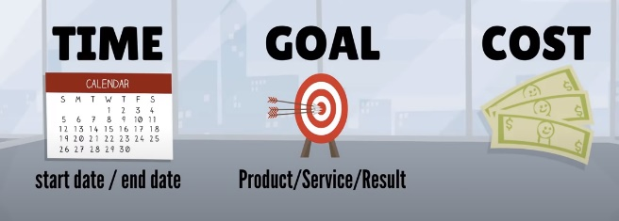project need you make a big effect in order to achieve a unique or specific goal…

project need show start date or time and finish date or time

## Please put your learning notes here:

## Project management basic

## Project management History

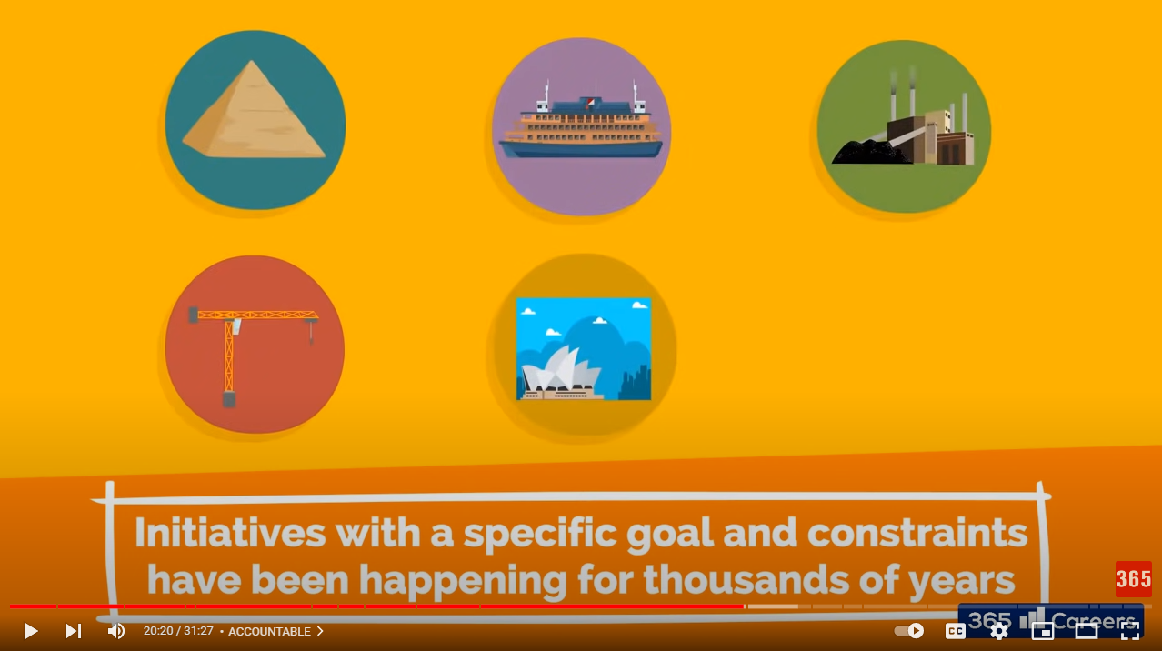

Good example is: Ancient Egypt build a big project!

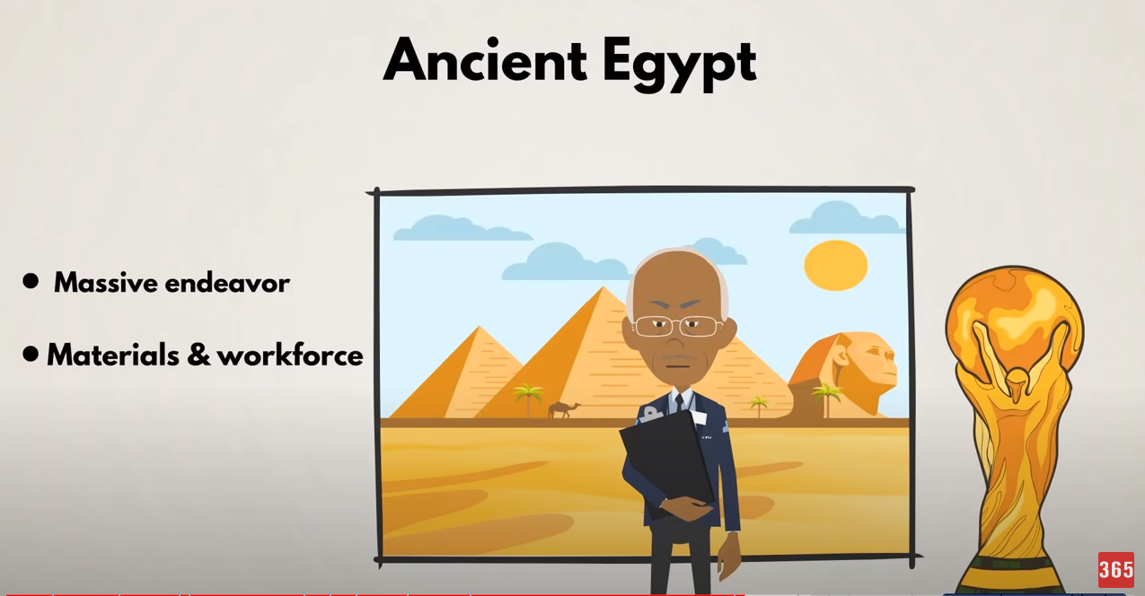

20 Century the Henry Gantt first make Gantt Chart Diagram. It is the revolution to know more about project management.

## Project management in the future

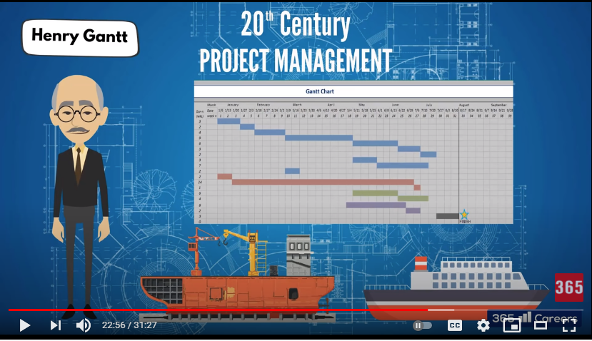

## Project Team

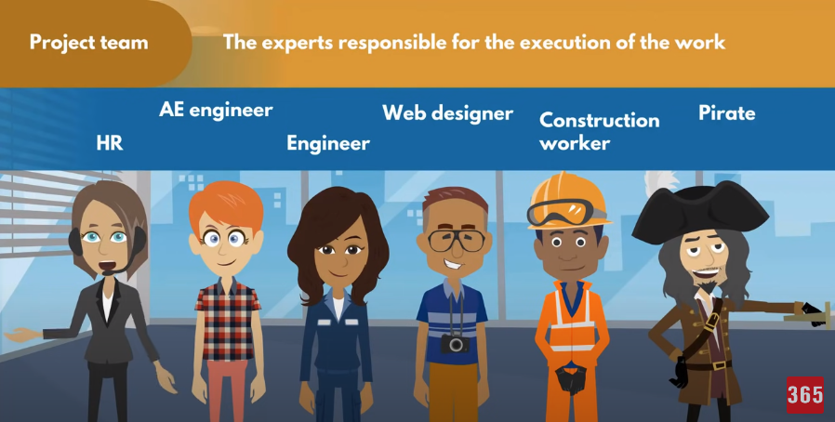

The experts responsible for the execution of the work

## Document Search Index

A

a GANTT chart 2

M

mission and strategy 3

mission statement 3

O

organizational change 3

P

project stakeholders 2

projects integration 2

S

successful implementation 3

U

understanding risk 4